CONTINUOUS ASSESSMENT EXAM (Re-test)
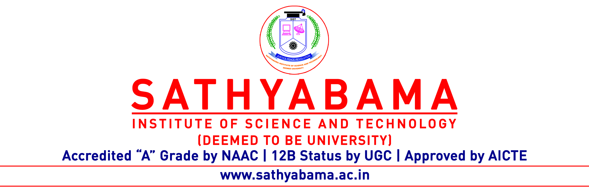
Program : B.E/B.Tech - CSE/IT Max. Marks : 30
Course : COMPUTER GRAPHICS AND MULTIMEDIA SYSTEMS Time : 1 Hour
Course code : SCS1302 Sem : V
Batch : 2018-2022 Date : 19.11.2020
Part-A Answer ALL the questions (5×2=10)

Q.No | Questions | CO (L)
 | Formulate the initial decision parameter P₀ used in Bresenhams Line drawing algorithm. | 1(6)
 | Translate the point A(3,4) with tx=ty=2 and find A’. | 2(5)
 | Which curve follows the property of being continuous and not differentiable? | 3(2)
 | Compare and contrast the Object Space Method and Image Space Method. | 4(4)
 | Scale the point A(3,4,5) with Sx=Sy=Sz=2 and find A’. | 3(5)

Part-B Answer ALL the questions (2×10=20)

Q.No | Questions | CO (L)
 | Sketch the working model of CRT along with Shadow mask method. | 1(4)
 | (OR)
 | Clip the Line, L1 with A(9,50) and B(60,120) using Nicholl- Lee-Nicholl Line Clipping algorithm. | 2(5)

 | Narrate how 3D object representations are done and construct a model using CSG. | 3(5)
 | (OR)
 | Compare and Contrast various Color Models and applications. | 4(5)

